**Programming Fundamentals**

**Lab Report**

**Lab 10**



|  |  |
| --- | --- |
| Group Members Name & Reg #: | **Muhammad Haris Irfan**  **(FA18-BCE-090)** |
|  |  |
| Class | Programming Fundamentals CSC103 (**BCE-2B**) |
| Instructor’s Name | Dilshad Sabir |

**In Lab Tasks**

**Question no: 1**

•Your task is to declare a 2D array whose dimensions should be entered by the user of the program.

•Then you should initialize the array with ones (using nested loops).

•Next you have to write a function array_multiply() which takes in the array or its pointer as argument and multiplies all its entries with a user input number. (Hint: you will also need to pass in the dimensions of the matrix to this function).

•Similarly write a function array_add() that adds a constant number to all the entries in a 2D array.

•Print the results of calling these functions.

**Solution:**

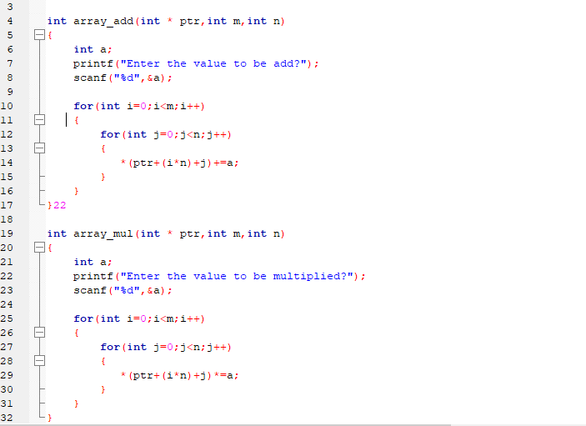The Code for the following code is attached below,

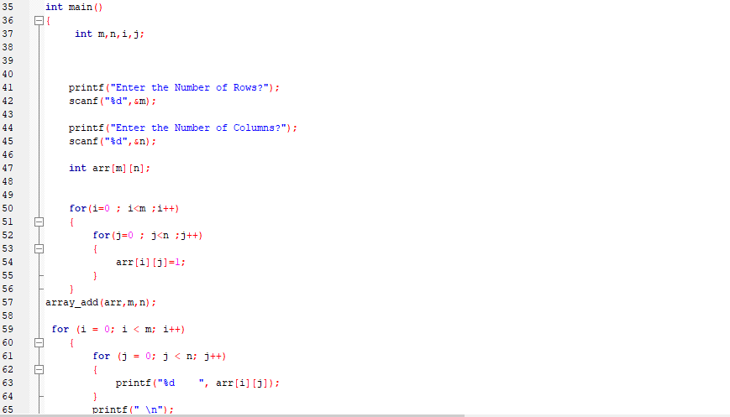

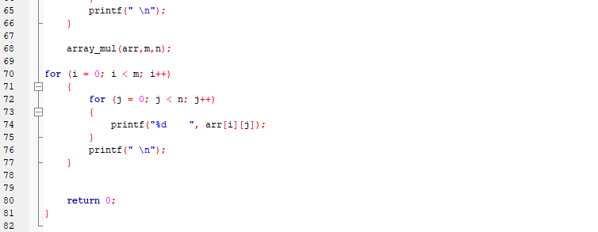

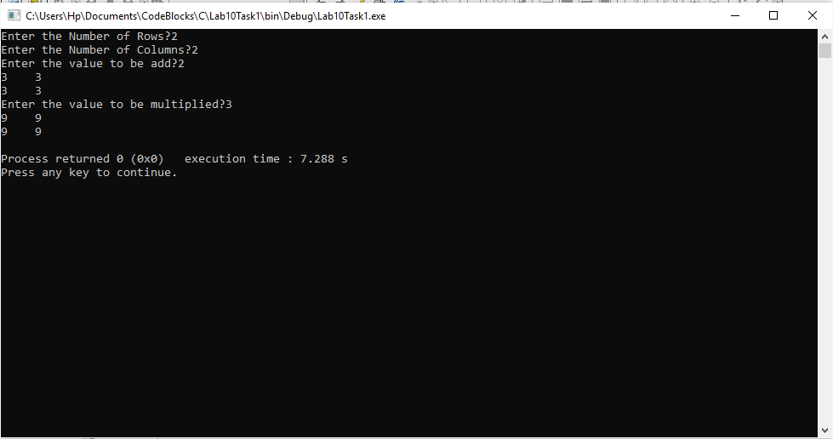The Result of the following code is attached below:

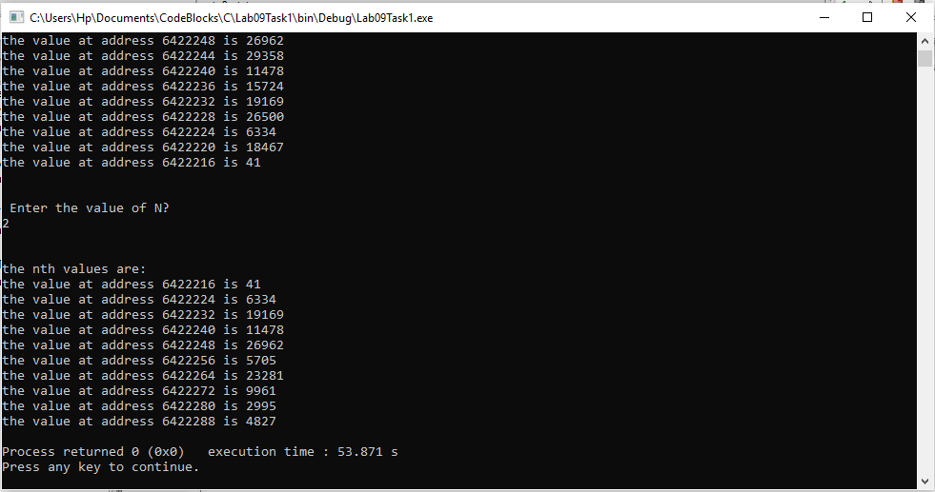

The output result verifies that our code is correct.

-------------------------------

**Question no: 2(A)**

In this task you have to make a magic square and display it on the screen. You are given a Starter

Code (Annex I), that does the following:

•Asks the user to enter the order ‘n’ of the magic square (odd numbers only).

•Declares a 2D array of size n x n and initializes it with zeros.

•Prints the magic square on the screen.

Your job is to complete this code by implement the algorithm discussed in the Reading Task 2.

Solution

The code is shown below for the given program and its results are given below,

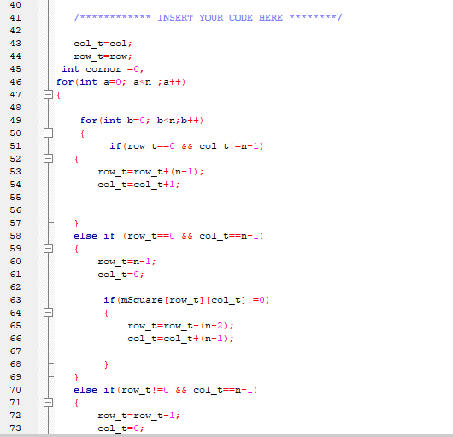

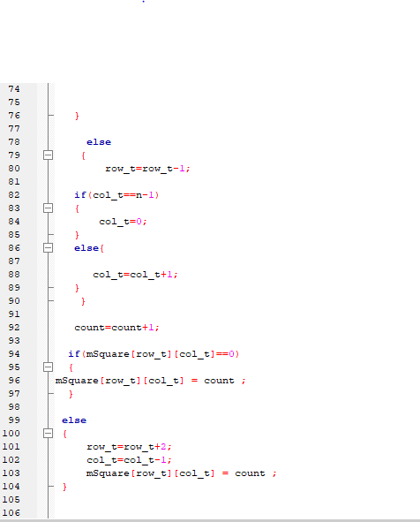

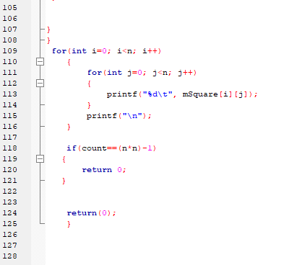

This code fills the magic square for odd numbers.

For n=5

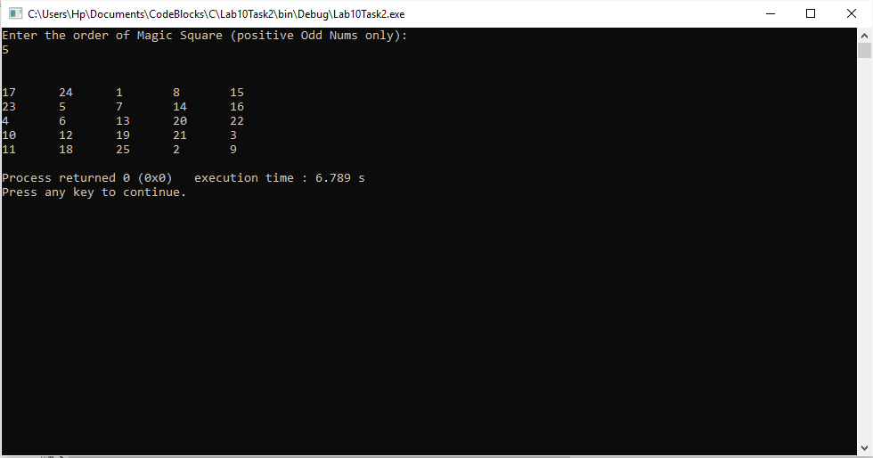

For n=3

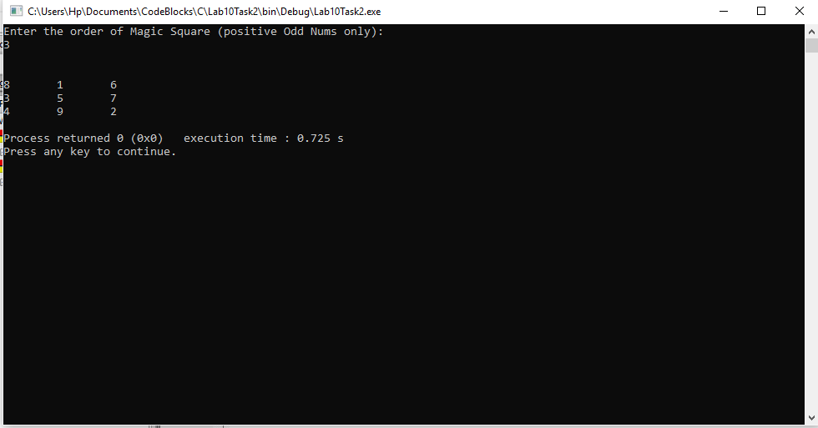

Our program works correctly for all entered odd values, hence our program is correct..

------------------------------

THE END

*there was no post lab for this lab.